
2020上海国际供热技术展览会
Shanghai International Exhibition on
Heating Technology 2020

亚洲权威供热行业品牌展 – 积累、沉淀、升级、突破！
AUTHORITATIVE HEATING INDUSTRY EXHIBITION IN ASIA – Accumulation·Precipitation·Upgrading·Breakthrough!

历经多年的稳扎稳打、不断升级转型，HEATEC《上海国际供热技术展览会》逐步成为供热行业内中外名优企业公认的国际化、多元化的专业平台，同时也为推动环保供热行业的节能低氮、智能高效发展做出贡献。2020作为十三五规划的收官之年，HEATEC将继续秉持着专业的态度，在2020年末为工商业界用户带来一场亚洲地区极具规模及影响力的供热盛宴。

此外，HEATEC 2020将与雅式集团旗下的两场专业展同期同地举办，届时“供热锅炉”、“电力电工”、“数据中心”三足鼎立，相辅相成，必将带动大批高质量的工商业终端买家用户莅临现场交流采购。

After years of steady development and constant upgrading, HEATEC has gradually emerged as an international, diversified and professional exhibition platform highly recognized by the notable Sino-foreign enterprises within the heating sector. In the meantime, HEATEC is also in a position to contribute to the proliferation of green heating industry by promoting the concepts of Energy Conservation and Low NOx as well as Intelligence and High Efficiency. 2020 is the final year of China's 13th five-year plan, HEATEC will continue to serve the industry with its professionalism and present a large-scale and influential feast to the industrial and commercial users within the heating realm in Asia.
Above all, two professional trade fairs organized by Adsale Group pertaining to "Electric Power and Electrical Engineering" as well as "Data Center" technologies will be held in conjunction with HEATEC 2020. At that time, the 3 interrelated concurrent exhibitions will surely pull in abundant high-quality industrial and commercial endusers and buyers to the fairground.

2020年预计展会规模 PROJECTED EXHIBITION SCALE

- 展场面积 Exhibition Area: 32,000平方米sqm
- 展商数目 No. of Exhibitors: > 280
- 观众数目 No. of Visitors: > 14,000

2019展会精彩回顾 REVIEW OF HEATEC 2019

参展商统计Exhibitor Statistics

- 展场面积 Exhibition Area 28,000平方米 sqm

- 展商数目 No. of Exhibitors
共计250家参展商，16个国家 / 地区，包括中国、奥地利、加拿大、丹麦、芬兰、法国、德国、中国香港特别行政区、意大利、日本、韩国、荷兰、瑞典、土耳其、英国及美国等。
250 exhibitors came from 16 countries / regions including China, Austria, Canada, Denmark, Finland, France, Germany, Hong Kong SAR, Italy, Japan, Korea, Netherlands, Sweden, Turkey, UK and USA.

- 主要参展商 Major Exhibitors
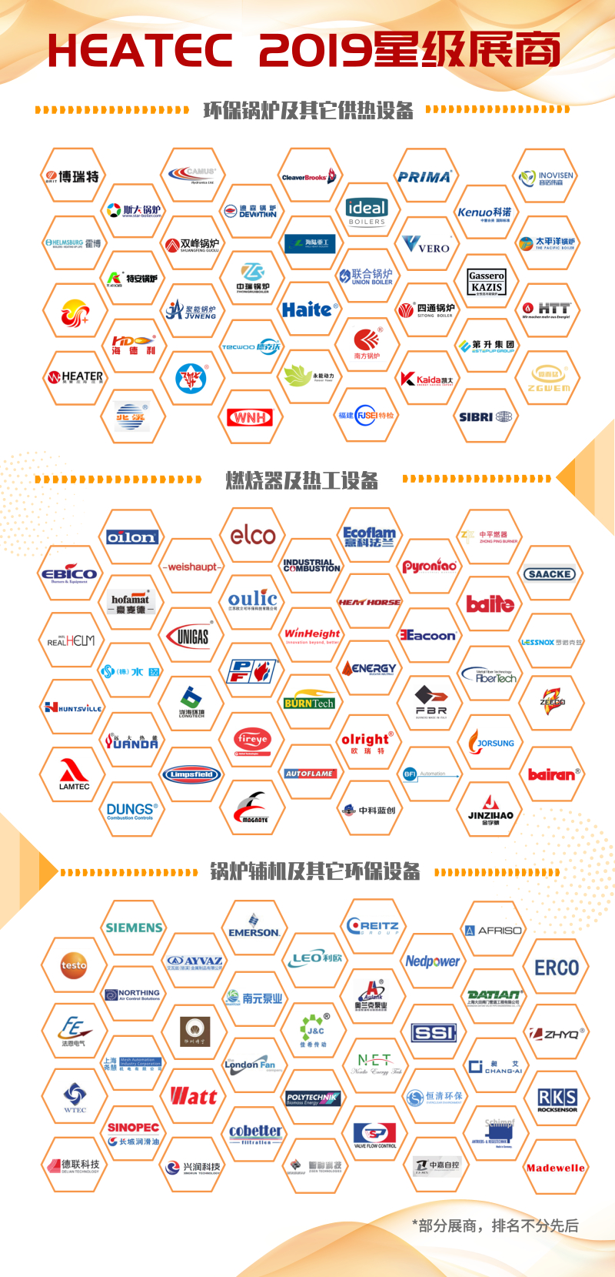
观众统计VISITOR STATISTICS

- 观众数目 No. of Visitors：
为期三天的展览会共接待了10,826人次，其中包括来自：阿尔及利亚、澳大利亚、孟加拉国、中国、埃及、法国、德国、中国香港特别行政区、印度、印度尼西亚、伊朗、以色列、意大利、日本、韩国、黎巴嫩、马来西亚、蒙古国、荷兰、朝鲜、巴基斯坦、俄罗斯、沙特阿拉伯、瑞典、叙利亚、台湾省、泰国、土耳其、英国、乌克兰及越南共31个国家及地区的中外观众。

The 3-day show had attracted 10,826 visitors coming from 31 countries / regions, including Algeria, Australia, Bangladesh, China, Egypt, France, Germany, Hong Kong SAR, India, Indonesia, Iran, Israel, Italy, Japan, Korea, Lebanon, Malaysia, Mongolia, Netherlands, North Korea, Pakistan, Russia, Saudi Arabia, Sweden, Syria, Taiwan Province, Thailand, Turkey, UK, Ukraine and Vietnam.

- 观众按行业分类 Visitors by Business Sectors
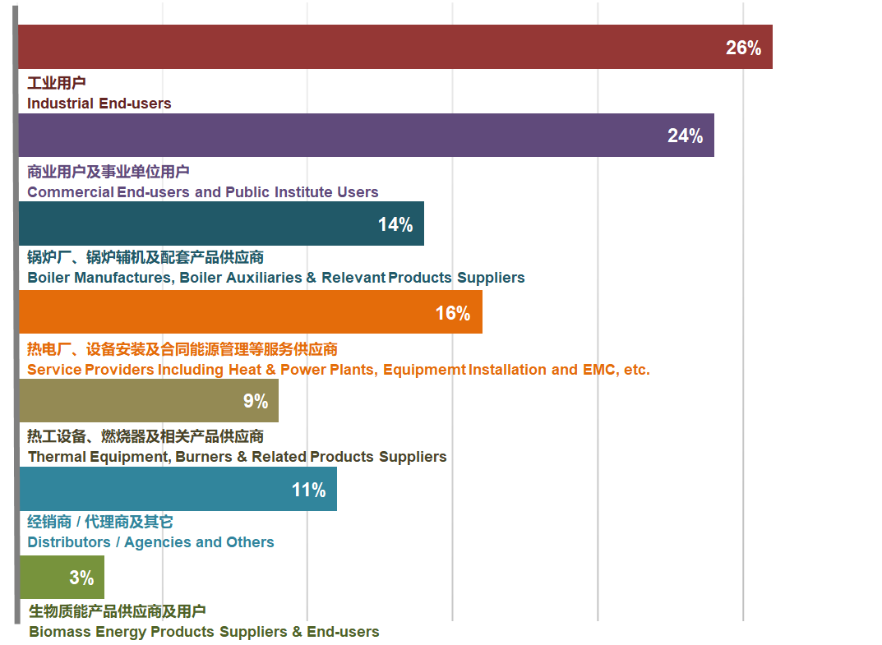

- 观众按地区分类 Visitors by Geographical Area
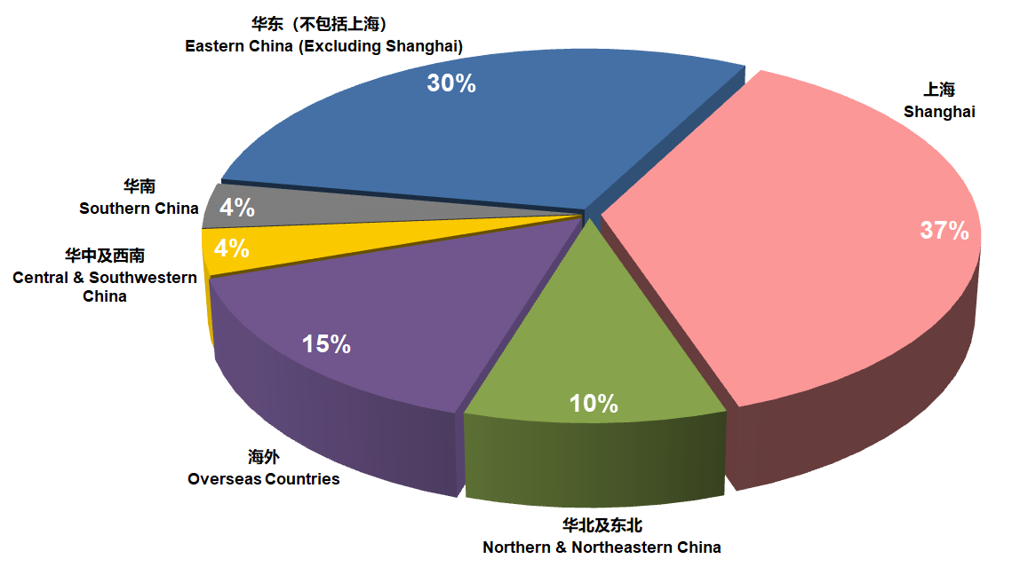

- 专业观众及买家覆盖十大工商业领域 Professional Visitors & Buyers Covering 10 Major Industrial and Commercial Sectors
食品 Food
统一 Uni-President / 稻香村 Daoxiangcun / 味之素 Ajinomoto / 莫林食品 Molin Food / 味之佳 Weizhijia / 新黄海食品 New Huanghai Food / 味元食品 Weiyuan Food / 长汇食品 Changhui Food / 天奕香料 Tianyi Fragrange Flavour / 土耳其Kervan糖果厂 Kervan (Turkey)
饮料/酒类 Beverage / Brewery
农夫山泉 NongFu Spring / 伊利 Yili / 味全 Weichuan / 怡宝 Yi Bao / 蒙牛Meng Niu / 麓卡威酒庄 Luckawi Winery / 金枫酒业 Jinfeng Wine / 大陆酿造 Mainland Brewing / 巴克斯酒业 Bacchus Liquor / 以色列耶路撒冷罐装啤酒厂 CANAAN BEER The Beer of Jerusalem
日化 / 医药 Daily Chemical / Pharmaceutical
飞利浦 Philips / 养生堂 YST / 狮王 Lion / 狮皇日用化工 Shihuang Daily Chemical / 国药集团 Sinopharm / 宝龙药业 Bao Long Pharm / 中医大药业 Shanghai TCMU Pharmacy / 万合制药 Wanhe Pharmaceutical / 华新生物 Huaxin Biotechnology / 上药药材 Shanghai Traditional Chinese Medicine
化工 / 纺织印染 Chemical / Textile / Printing & Dyeing
巴斯夫 BASF / 赢创特种化学 Evonik / 仕通化工 Shitong Chemical / 华友化工 Huayou Chemical / 物产化工Materials Industry Chemical Group / 长春化工 Changchun Chemical / 国纺企业 Lovetex Industrial / 宝利缝制设备厂Baoli Sewing Equipment Factory
汽车 / 汽配 Automobile / Auto Parts
一汽丰田 Toyota / 三菱 Mitsubishi / 佳通轮胎 Giti / 阿雷蒙Araymond / 奥捷汽配 Aojie Auto Parts / 威克迈龙川汽车发动机零件Weikemai Longchuan Automobile Engine Parts / 宝钢集团 Bao Steel / 中华造船厂 China Shipbuilding / 沪东中华造船集团Hudong Zhonghua Shipbuilding Group / 豫新汽车热管理科技 Yuxin Automobile Heat Management Technology
酒店 / 宾馆 Hotels
衡山集团 Hengshan Group / 香格里拉大酒店 Shangri-la Hotels and Resorts / 锦江国际酒店集团 Jin Jiang International / 绿地万豪酒店 Marriott Hotel Riverside / 东湖集团 Donghu Group / 和平饭店 Peace Hotel / 上海迪士尼乐园酒店Shanghai Disneyland Hotel / 王宝和大酒店 Central Hotel / 金水湾大酒店 Golden River-view Hotel
学校 Schools
清华大学 Tsinghua University / 上海交通大学 Shanghai Jiao Tong University / 东华大学Donghua University / 上海理工大学 University of Shanghai for Science and Technology / 南通大学 Nantong University / 哈尔滨工业大学 Harbin Institute of Technology / 浙江大学 Zhejiang University / 上海市医药学校 Shanghai Medical School
工程公司 / 地产开发商 Engineering Company / Property Developer
中国燃气 China Gas / 中国电力建设工程咨询 CPCEC / 中国联合装备集团 CNBM / 中国石油天然气第八建设 CNPC / 中国核工业第五建设 CNNC / 上海公路桥梁集团 SRBG / 可高工程建设 Kegao Engineering Construction / 创伟建筑工程 Chuangwei Construction Engineering / 天地成工程建设集团 Tiandicheng Engineering Construction Group / 鹏达设备安装 Xian Pengda Equipment Installation / 中亚工程 Mid-Asia Engineering Technology / 恒大集团 Evergrande / 中南置地 Zoina / 振兴集团 Zhenxing Group
设计院 / 研究院 Design Institutes / Research Institutes
中国电子科技集团公司第四十八研究所 CETC / 中国船舶重工集团第七一一、七〇四研究所 CSSC / 中国能源建设集团辽宁电力勘测设计院 CEEC / 同济大学建筑设计研究院 TJAD / 上海航天技术研究院 SASC / 中燃哈工大技术研究院 CG-HIT / 上海市机电设计研究院 SIMEE / 上海化工研究院 SRICI / 清华大学煤燃烧工程研究中心 Tsinghua University Coal Combustion Engineering Research Center
市政单位 / 服务供应商 Municipal Units / Service Providers
上海市环保局 Shanghai Environmental Protection Bureau / 上海市经信委Shanghai Municipal Commission of Economy and Informatization / 浙江省经信委 Economy and Information Technology Department of Zhejiang / 浙江省德清县投促局 Investment Promotion Bureau of Deqing County, Zhejiang Province / 上海市能效中心 Shanghai Energy Efficiency Center / 中国电信 CDMA / 中国农业银行Agricultural Bank of China / 国家电投 SPIC / 哈尔滨电气集团 Harbin Electric Corporation /上海电力股份 Shanghai Electric Power / 上海燃气 Shanghai Gas

展品范围 SCOPE OF EXHIBITS

各类锅炉Various Kinds of Boilers

- 燃油燃气工业锅炉Oil-fired (Gas-fired) Industrial Boilers
| 蒸汽锅炉steam boiler | 热水锅炉hot water boiler | 有机热载体锅炉organic heat transfer material boiler |
- 燃油燃气商用锅炉Oil-fired (Gas-fired) Commercial Boilers
| 冷凝式锅炉condensing boiler | 燃气供暖锅炉gas-fired heating boiler | 热水机组 hot water unit | 蒸汽发生器steam generator | 真空锅炉vacuum boiler | 贯流锅炉tabular boiler | 铸铁锅炉、铸铝锅炉cast iron boiler, cast aluminum boiler |
- 生物质锅炉 Biomass Boilers
- 电锅炉 Electric Boilers
| 电阻式电热锅炉 resistance type electric heating boiler | 电极式电热锅炉
electrode type electric heating boiler | 电磁感应加热锅炉 electromagnetic
induction heating boiler |
- 余热锅炉技术和产品Waste Heat Recovery Boiler Technology and Products
- 垃圾、污泥焚烧处理技术及系统设备Solid Wastes, Incineration Technology and Systemic Equipment
- 废气利用设备Exhaust Gas Utilization Equipment
- 燃煤锅炉Coal-fired Boilers
| 工业煤粉锅炉industrial pulverized coal boiler | 循环流化床锅炉等circulating fluidized bed boiler |

燃烧器、热工设备与技术Burners and Thermal Equipment & Technology

- 锅炉燃烧器Boiler Burners
- 燃烧器配件Burner Spare Parts
| 油泵oil pumps | 烧嘴nozzles | 压力开关 pressure switches |
- 工业燃烧器 Industrial Burners
- 工业加热炉 Industrial Heating Furnaces
- 干燥及烘干设备 Drying Equipment
- 热风炉Hot-blast Stove
- 工业热风机 (加热器) Industrial Hot Air Blowers（Heater）
- 油田加热炉 Oilfield Heating Furnaces
- 蓄热器、热交换设备 Heat Accumulators, Heat-exchangers
- 电加热元件 Electric Heating Element
- 电热管Electric Heat Pipe
- 电磁感应加热元件Electromagnetic Induction Heating Element
- 锅炉炉排Stoker Grates

锅炉替代产品及其它热能设备 Boiler Replacement Products and Other Heating Equipment

- 工业和家用冷热电联供技术与产品Industrial and Home Use Combined Cooling Heating and Power (CCHP) Technology and Products

- 热泵 Heat Pumps
| 工业余热industrial waste heat | 空气源air source | 水源water source | 地源ground source |
- 太阳能供热设备Solar Energy Heating Equipment

锅炉零部件及配套产品Boiler Parts and Ancillary Products

- 泵 Pumps
- 阀门Valves
- 风机Fans
- 自动控制装置Automation Controlling Equipment
- 仪器仪表 Instrumentation
| 温度/压力/流量计量、控制、调节temperature/pressure/flow measure, control and adjustment |
- 安全装置Safety Devices
- 报警装置Alarm Devices
- 散热管Heat Pipes
- 翅片管Finned Tubes
- 垫片Gaskets
- 密封件Seals
- 清洗设备Cleaning Equipment
- 锅炉、热能系统控制软件Boiler, Thermal System Control Software
- 系统能源统计分析咨询诊断软件System Energy Statistical Analysis Consultation Diagnosis Software

锅炉制造装备及原材料Boiler Manufacturing Equipment and Raw Materials

- 材料处理与下料设备Material Handling and Blanking Equipment
| 钢材预处理设备steel pretreatment equipment（喷砂装置sandblasting device）| 数控下料设备（火焰、等离子、激光、水力）CNC blanking equipment (flame, plasma, laser, hydraulic) | 机械下料设备（带锯、圆锯、剪板机）mechanical blanking equipment (band saw, circular saw, shearing machine) | 倒角机chamfering machine | 刨边机 edge planing machine |
- 金属成型设备Metal Forming Equipment
| 卷板机coiling machine | 管端成型机pipe end molding machine | 数控弯管机CNC bending machine | 折弯机 bending machine | 折边机edge folding machine | 炉胆成形设备furnace liner forming equipment | 胀接设备expansion and connection equipment |
- 焊接设备 Welding Equipment
| 各类焊机welding machines | 纵环锋焊接装置longitudinal ring front welding device | 膜式壁、蛇形管、翅片管等专用焊接装置special-purpose welding device for membrane wall, serpentine tube and finned tube | 焊接变位机welding positioner | 电动滚轮架electric roller |
- 加工设备Processing Equipment
| 车削turning | 刨削planing | 钻孔drilling | 铣削milling | 镗削 boring |
- 无损检测技术与设备NDT Technology and Equipment
- 检验试验仪器仪表及设备 Inspection & Examination Instrumentation and Equipment
| 材料理化检验设备 materials physicochemical property inspection and testing equipment | 热工环保性能检验检测仪器仪表 thermal environmental performance inspection & examination instruments |
- 原辅材料Raw and Auxiliary Materials
| 板材 steel plate | 型钢section steel | 管材pipes | 各类焊材 all kinds of welding materials |

节能减排技术和产品Energy-saving & Emission Reduction Technology and Products

- 节能器、省煤器Energy Saver, Coal Economizer
- 锅炉水处理技术和设备 Boiler Water Treatment Technology and Equipment
- 冷凝水回收技术与系统设备Condensing Water Recovery System Technology and Equipment
- 烟气净化设备Flue Gas Purification Equipment：
| 除尘器dust remover | 脱硫脱硝技术和设备desulphurization and denitrification technology and equipment |
|

生物质能产品与技术Biomass Energy Products and Technology

- 生物质固体颗粒燃料制备设备 Solid Biomass Pellet Fuel Preparation Equipment
- 生物燃气制备系统和设备Bio-Gas Fuel Preparation Systems and Equipment
- 生物质锅炉燃烧设备 Burning Equipment for Biomass Boilers
- 生物质干燥及烘干设备Biomass Drying Equipment

重量级同期论坛 INFLUENTIAL CONCURRENT FORUMS

主办单位将携手众多权威性的行业协会，围绕“环保供热”、“节能低氮改造”、“热泵采暖技术”等话题，在HEATEC 2020同期举办一系列专业论坛及技术研讨会。届时业内专家、终端用户、名优企业等相关单位将莅临现场交流分享。

The show organizers and supporters will work jointly in organizing a series of professional forums and technical seminars pertaining to “Environmental Heating”, “Energy-saving Low Nitrogen Transformation” and “Heat Pump Heating Technology”, etc. Experts, end users and leading enterprises will be gathering together for discussing and exchanging.

主办单位 Organizers:
中国电器工业协会工业锅炉分会 Industrial Boiler Branch of China Electrical Equipment Industrial Association (CIBB)
上海工业锅炉研究所有限公司 Shanghai Industrial Boiler Research Institute Co., Ltd. (SIBRI)

承办单位 Co-organizers:
雅式展览服务有限公司 Adsale Exhibition Services Ltd.
雅展展览服务（上海）有限公司 Adsale Exhibition Services (Shanghai) Ltd.

支持单位 Supporters
上海市节能协会
Shanghai Energy Conservation Association
上海塑料行业协会
The Plastic Trade Association of Shanghai
上海市酿酒专业协会
Shanghai Drinks Association
上海市食品协会
Shanghai Food Association
上海医药行业协会
Shanghai Pharmaceutical Profession Association
上海市节能工程技术协会
Shanghai Energy saving Engineering and Technology Association
上海市循环经济协会集中供热热电联产专业委员会
Shanghai Association of Circular Economy - Central Heating Cogeneration Professional Committee
上海仪器仪表行业协会
Shanghai Instrument Industry Association
上海市化工行业协会
Shanghai Chemical Industry Association
上海市新材料协会
Shanghai Society for Advanced Materials
上海电子商会（上海电子制造行业协会）
Shanghai Electronic Chamber of Commerce (Shanghai Electronics Manufacturers Association)
上海电线电缆行业协会
Cable-Wire Industries Association of Shanghai (CAS)

湖北省医药行业协会

Pharmaceutical Profession Association of Hubei Province
江西省食品添加剂和配料协会

Jiangxi Food Additives & Ingredients Association
浙江省洗涤行业协会

Zhejiang Laundry Association
常州市节能和新技术协会
Changzhou Energy Saving & New Technical Association
苏州市食品行业协会
Suzhou Food Industries Association
杭州市食品工业协会
Hangzhou Food Industry Association


展会查询ENQUIRIES
雅展展览服务（上海）有限公司
Adsale Exhibition Services (Shanghai) Ltd.
电话Tel: 86-21-51879766 传真Fax: 86-21-64693665 电邮E-mail: boiler@adsale.com.hk

上海工业锅炉研究所有限公司
Shanghai Industrial Boiler Research Institute Co., Ltd. (SIBRI)
电话Tel: 86-21-34781959*331 / 332 传真Fax: 86-21-54395873 电邮 E-mail: glxh09@163.com

